Test cases:

* Used only common item names without specifying the proper name ,company name etc.

Test case 1:

1. Problem-bill for commodities as follows-

|  |  |
| --- | --- |
| Product | quantity |
| pasta | 3 |
| wiper | 1 |
| shampoo | 5 |

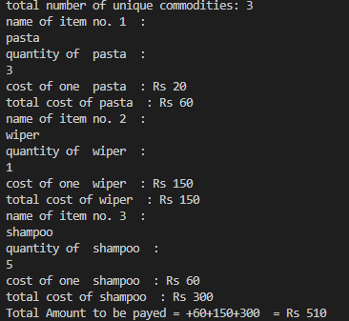

1. Problem-bill for commodities as follows-

|  |  |
| --- | --- |
| Product | quantity |
| oil | 4 |
| honey | 7 |
| soap | 5 |
| cream | 3 |

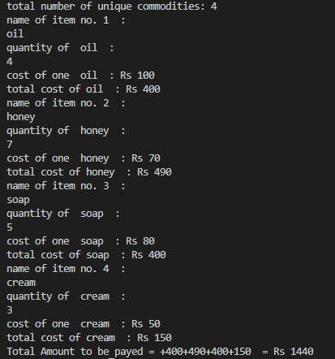

1. Problem- items to be added as follows-

|  |  |
| --- | --- |
| Product | quantity |
| broom | 10 |
| pen | 30 |
| soap | 40 |
| honey | 25 |